|  |
| --- |
|  |



**15 February 2013** **The Weekly Bulletin of Rotary Club of Kathmandu Mid-Town** **Bc-15.2/012-13**

**District : 3292 Web: www.rotarymidtown.org.np Club Id : 26776**

**FEBRUARY IS WORLD UNDERSTANDING MONTH**



To observe this designated month, clubs arrange

International speakers, invite Youth Exchange students and

international scholars from schools and universities to club

meetings, plan programs featuring former Group Study

Exchange team members, arrange discussions on global

issues, present entertainment with an international cultural

or artistic theme, and schedule other programs with an

international emphasis.

Friday, 8 January:

Guest Speaker, Dr. Sushil Koirala, Chairman of National Dental Hospital Ltd, Kathmandu. highlighted about snoring and their early management through dental sleep medicine technology, in his interesting presentation.

**Off-site Board Meeting**

A historic first-ever off-site Board Meeting of the Club was held at Lumbini on Saturday, 9 February. Though such a meeting was planned in the past, but somehow not materialized, this time nine Board members could do it, thanks to PP Ajay, Treasurer Jo, and PE Saroj.



"The Rotary Club of Kathmandu Mid-Town had a historic Board Meeting on Saturday, Feb

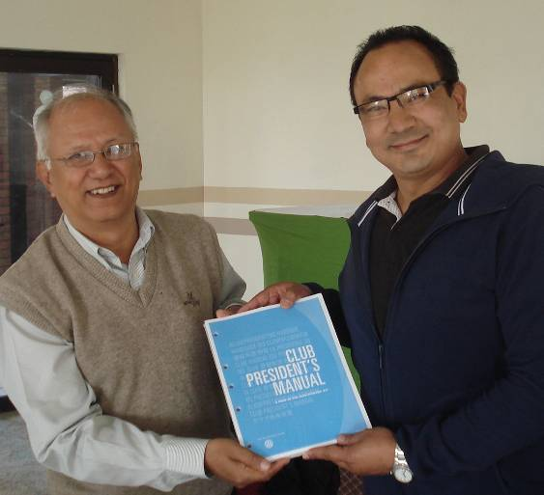

9th. Nine Board Members made the pilgrimage to Lumbini for the first ever off-site meeting.

The meeting was hosted by PP Ajay, with complimentary room and board provided to all

Members and their spouses at the lovely Lumbini Garden Hotel. The transportation was

arranged for by Treasurer Jo, while PE Saroj treated fellow travellers to lunch in

Narayanghat on the way to Lumbini. Warm fellowship was enjoyed by all both during the

travel and at the en route stop in Nawalparasi where the Mid-Town Board received a hearty

welcome at the farm of Rtn. Pabitra. One of the highlights of the Meeting was when Pres.

Devendra presented PE Saroj with the Rotary documents for the coming year. After the

Board Meeting our Mid-Towners took in the sights and in the photo below they are at the

 Lumbini Peace Pagoda."*(More photos in the annex)*

*courtesy:* Rtn Dr Isabella C Bassingana Khadka

# Weekly Meetings and Programs :

|  |  |  |
| --- | --- | --- |
| Date | Program/Speaker | Program/Topics of Presentation |
| 15 Feb 2013 | ??? |  |
| 22 Feb 2013 | Rtn Anja Møller Rasmussen | ICIMOD's Youth Initiative |

Friday, 15 February:

???

**Congratulations:**

**Congratulations to PP Ambica Shrestha !**

District Governor has confirmed nomination of our PP Ambica and now she is the member in the DG Nomination Committee for RY 2015/16.

**Congratulations to PP Dr Lekha Tuladhar and Rtr PP Kishor Acharya !**

PP Dr. Lekha and Rtr. PP Kishor Acharya received a recognition for exemplary contribution in the successful execution of "Extensive Free Eye Camp" organized by Rotaract Club of Ktm MidTown, a recognition from  Rotaract South Asia Multi-District Information Organization.

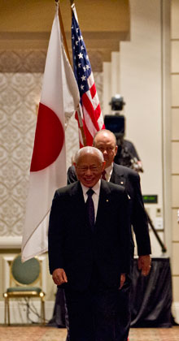

Putting Service Above Self allows us to focus our energies on what is truly important. We put

the common good above our own. We value the needs of others over our own desires. We think less about ourselves and more about what is best for everyone. And in this way, we help

to build the foundation for a more peaceful world.

**RI President Sakuji Tanaka**

**Committee Chairpersons' Column:**

**???**

**Past Presidents' Column:**

This is the column, started from the first week of Jan 2013, set aside for the PP's, to share their Rotary experiences, their opinions, and thoughts on any issues pertaining to the club or Rotary in general.

But so far, PPs have not come forward to use this column for the benefits of club members !

There are many areas where PPs could contribute –

Why you are a Rotarian ?

Your experience in handling community/vocational projects, your days when you were the Club President, your experience as Rotary district official, loopholes in club administration, loopholes in district management as you see it, future of Rotary in Nepal, first-hand remark on any Rotary program/activity or project, any suggestion for incumbent Club President, for future presidents, Rotary as you see it; or

some interesting jokes in terms of your day-to-day life, in Rotary, etc.

Come on, PPs, you are the leader, why wait for someone to start ?

On Lighter Side :

Click here ⇩



A thought for the day:

**There may be times when we are powerless to prevent injustice,**

**but there must never be a time when we fail to protest.**

- Elie Wiesel

*courtesy:* Rtn Dr Isabella C Bassingana Khadka

Great quotes:

***It is very easy to defeat someone;   
but it is very hard to win over someone !***

Number game:

If a = b2; b = a - c; c = b2 - b; and a + b + c = 50

find the value of a, b, and c.

Last week's solution: the value of a = 5, b = 4, and c = 3

Congratulations to Rtn Rabi for getting the correct answer.

NB: Send any informations/photos that may be of interest to the Club or Rotarians in general to

BC Editor: RR Shrestha email: rryesrr@gmail.com

## 15Feb 2013 The Weekly Bulletin of Rotary Club of Kathmandu Mid-Town bc-15.2/012-13

**Annex**

**Rotary Club of Kathmandu Mid-Town**

**Board Meeting, Feb.9, 2013**



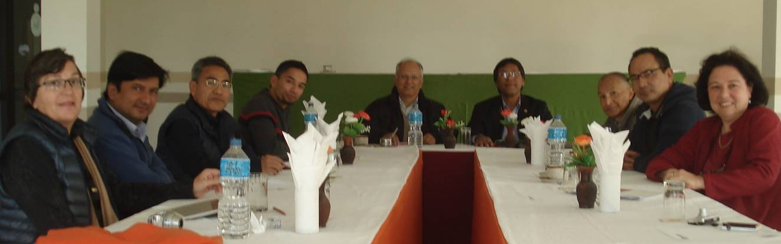

The Rotary Club of Kathmandu Mid-Town had a historic Board Meeting on Saturday Feb.9th. Nine Board Members made the pilgrimage to Lumbini for the first ever off-site meeting. The transportation was provided by **Treasure Rtn. Yo** and the complementary accommodations were arranged at the lovely Lumbini Garden Hotel by **PP Ajay.** Warm fellowship was enjoyed by all both during the travel and at the en route stop in Nawalparasi where the Mid-Town Board received a hearty welcome at the farm of **Rtn. Pabitra.** One of the highlights of the Meeting was when **Pres. Devendra** presented **PE Saroj** with the Rotary documents for the coming year (see photo). After the Board Meetingour Mid-Towners took in the sights and in the photo below they are at the **Lumbini Peace Pagoda.**

